### Project Design Phase - Part 1

### Proposed Solution

|  |  |
| --- | --- |
| **NM ID** | **8073B6FD2C609D2A026419D64F1FD32** |
| **PROJECT TITTLE** | **BUILD IN EVENT MANAGEMENT USING SALESFORCE** |

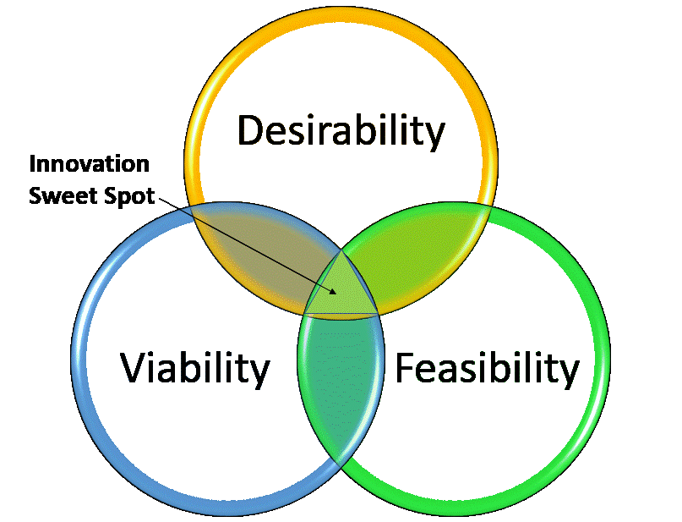

I often work with teams who are pursuing a grand vision, an idea that could really have an impact for their customers and for their business. This vision is fantastic, even necessary for keeping the team motivated and going in the right direction. But to wait until that vision is completely built to test for desirability, feasibility and viability is foolhardy. Tests for all three characteristics need to be built during implementation so that adjustments can be made to keep you on the right course. So, lets delve into the elements of the framework of this innovation process.

# Desirability — Are We Solving for the Right Pain Point?

A test for desirability focuses on whether your solution is a nice to have or a must have for your customer. Ask yourself, what task am I helping my customer complete? What does successful completion of that task look like for them? Looking at what they are trying to do and why it is important to them puts yourself in their shoes, lets you look at your solution from their eyes. If you are solving the key pain points they encounter when trying to complete this task, your solution has met the test for desirability. If not, and there are other pain points that you haven’t addressed, then pivoting your solution might put you on a better path.

*Desirability tests whether your innovation is solving the right customer problem*

As an example, let’s look at two emerging markets, car sharing and electric cars. The customers who are drawn to both are concerned about two things: the environmental impact of driving a gas-powered car, and the cost of ownership. Tesla has primarily focused on building cars that are environmentally friendly. While this works for an upscale niche of people, there are many others who can’t afford to have a Tesla sitting in their driveway, and who are concerned about both the cost of ownership and the environmental impact of building one car for every person.

So [Elon Musk pivoted last summer](http://www.businessinsider.com/musk-tesla-car-sharing-2016-7" \t "_blank) to think about both sides of the equation. Once his cars become autonomous, they can drive others around after their owner has reached their destination. This pivot can increase the desirability of the Tesla for their target customer, and provides direction for the design team to also build for share-ability.

# Feasibility — Are We Building on our Core Operational Strengths?

A test for feasibility measures the operational capabilities leveraged in a new solution. It asks the organization to look internally and objectively assess their strengths — technology, financial, branding, customer service, partnerships, etc. If a new solution can leverage ~80% of current operational capabilities, and new capabilities can be built where an organization is already strong, it will strengthen the foundation of the company and the competitive advantage of the business.

Feasibility asks the question, how can we build this solution to make our business healthier and stronger? If a solution requires building completely new capabilities, the investment is riskier because of the amount of resources required and because it may change the market’s perception of the company, not always for the better.

*Feasibility tests whether your innovation strengthens your business*

Often I see the worst offenders of the feasibility test in the “me too” innovators. These are businesses that see their competitors winning with a solution and feel the only way to keep up is to build a similar solution. They call this innovation — after all, it is something their business hasn’t done before. But their competitors have built their own operational strengths. Trying to mimic those strengths will incur a lot of effort for a solution that will probably always be in second place.

Looking at the Tesla example again, notice that they are not proposing they build a car sharing service and compete with Uber. Instead they are building on their core capabilities and brand strength to design an autonomous car that has been built for the sharing economy.

# Viability — Does Our Solution Contribute to Long-Term Growth?

The final test for your innovation focuses on the value chain of your solution to ensure that it is viable now and in the future. Testing for viability asks, does our business model fit with the way our customers want to use and pay for our solution? Is the way we build our solution and the way we buy from our suppliers profitable? Viability not only looks at profit, it also looks at sustainability to ensure that your business contributes to community and society.